# DATABASE SYSTEMS

# Hassaan Akbar Cheema

# Reg no. 174351

# Bscs6c

# Lab 11

**Task: Data of the updated Enrolled table is given in text format and also loaded at LMS. Write SQL expressions for each of the following queries and execute them, Use like operator for string matching and Join clause:**

1. Add new fields: dateFrom and dateTo in the enrolled table.

create table Enrolled(

snum integer references student.sname,

cname char(40) references class.name);

ALTER TABLE enrolled

ADD dateFrom date;

ALTER TABLE enrolled

ADD dateTo date;

1. Insert data in enrolled table.

insert into enrolled values

(112348546,'Database Systems','2010-11-11','2011-01-15'),

(115987938,'Database Systems','2010-09-15',NULL),

(348121549,'Database Systems','2009-08-15','2009-12-15'),

(322654189,'Database Systems','2010-10-10','2011-02-10'),

(552455318,'Database Systems','2010-10-10','2011-02-10'),

(455798411,'Operating System Design','2008-01-20', '2008-07-10'),

(552455318,'Operating System Design','2008-01-20', '2008-07-10'),

(567354612,'Operating System Design','2007-02-15', NULL),

(112348546,'Operating System Design','2010-09-15', '2011-01-15'),

(115987938,'Operating System Design','2006-02-01', '2006-06-30'),

(322654189,'Operating System Design','2006-02-01', '2006-06-30'),

(567354612,'Data Structures','2007-02-15','2007-07-25'),

(552455318,'Communication Networks','2010-10-10','2011-02-10'),

(455798411,'Optical Electronics','2009-08-15','2009-12-15'),

(301221823,'Perception','2009-08-15','2009-12-15'),

(301221823,'Social Cognition','2009-02-01', '2009-06-30'),

(301221823,'American Political Parties','2009-07-03','2009-09-30'),

(556784565,'Air Quality Engineering','2010-09-15', '2011-01-15'),

(099354543,'Patent Law','2010-10-10','2011-02-10'),

(574489456,'Urban Economics','2010-10-10','2011-02-10');

1. Print the level in lower case and the average age of those students who enrolled in 2008

for that level for all levels that include ‘R’.

select lower(s.level),avg(s.age)

from student s,enrolled e

where e.snum = s.snum

and dateFrom like '2008%'

group by level

having level like '%R%'

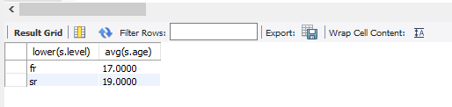

1. Find the names of all classes (initial capital) and their enrollment strength that have enrollment greater than 2.

select upper(c.cname),count(s.sname)

from enrolled e,class c,student s,faculty f

where c.cname=e.cname

group by (c.cname)

having count(c.cname)>2;

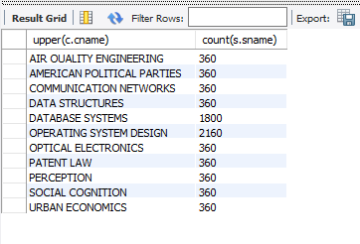

1. Find the names of faculty members (in upper case) and their department number together

who teach in room ‘R128’ in descending order.

select upper(f.fname),f.deptid

from faculty f,class c

where f.fid=c.fid and c.room='R128'

order by c.room desc;

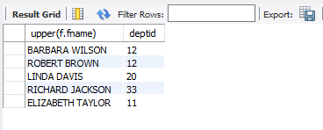

1. Fin the names of students who enrolled in June 2010 and majoring in any ‘Science’ in

ascending order.

select distinct s.sname, s.major

from student s,enrolled e

where e.snum=s.snum and e.dateTo='2010 06%' and major='%Science';

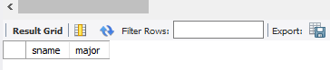

1. Find the names of faculty members that either teach to class ‘database systems’or not.

select f.fname,c.cname

from faculty f

left outer join class c on c.cname='Database Systems'

order by f.fname asc;

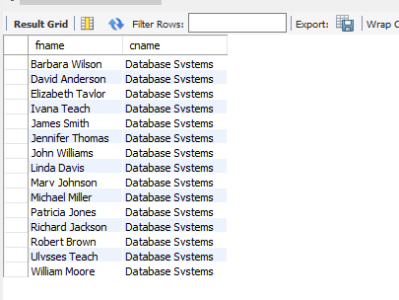

1. Find distinct student ages of those students who completed the course in the year in which he enrolled the couse, in ‘Database’ class.

select distinct s.sname,s.age,e.dateFrom,e.dateTo,c.cname

from student s,enrolled e,class c

where c.cname='Database Systems'

group by c.cname;

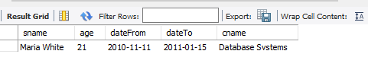

1. Find the name of students and completion month and year who enrolled in ‘Data Structures’.

select s.sname,e.dateFrom,e.dateTo,e.cname

from student s,enrolled e

where e.cname='Data Structures' and e.snum=s.snum;

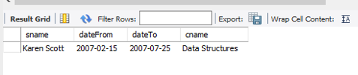

1. Find class names ether taught by faculty member: ‘Barbara Wilson’ or not.

select c.cname

from class c,faculty f

where f.fname='Barbara Wilson';

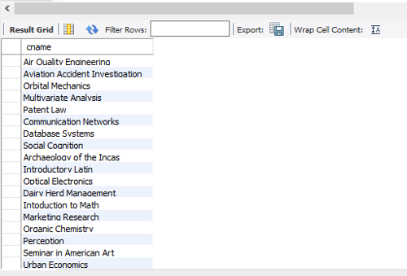

1. Find the name of teacher who does not teach to class: ‘Marketing Research’.

select distinct f.fname

from faculty f,class c

where f.fid=c.fid and c.cname!='Marketing Research';

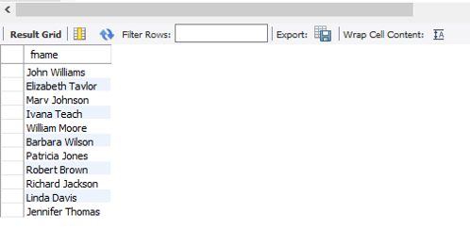

1. Find the names of faculty members that taught to class ‘database Systems’ in 2009.

select f.fname

from faculty f,class c,enrolled e

where f.fid=c.fid and c.cname=e.cname and e.cname= 'Database Systems'

and dateFrom like '2009/%' and dateTo like '2009/%';

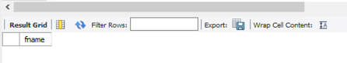

1. Find the name of course that was run only for three months.

select e.cname, timestampdiff(month,DateFrom,DateTo) as DifferenceDate

from enrolled e

group by e.cname

having differencedate = 3;

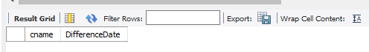

1. Find the names of students who enrolled but could not complete their courses.

SELECT distinct s.sname

from student s,enrolled e

where e.snum=s.snum and dateTo is null;

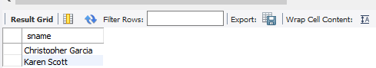

1. Find the names of students who completed their course in June.

select s.sname

from student s,enrolled e

where e.snum=s.snum and month(dateTo)=06;

